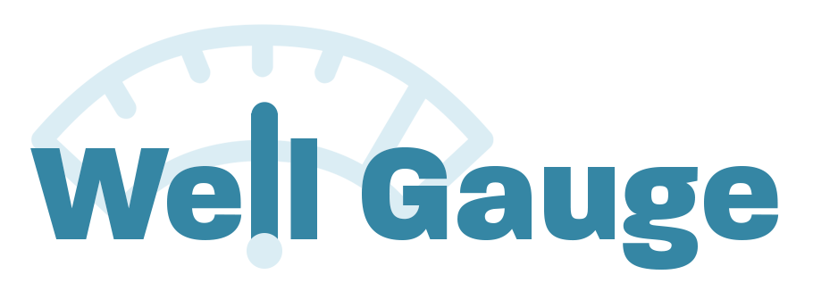

What is Well Gauge?
8-Minute Survey Tool to Gauge Your Organization’s Progress in Creating a Culture of Mental Wellness
Who is this designed for? HR, Benefits and DE&I Leaders
Who created this? A Northeast Business Group on Health task force of 15 business leaders and mental health professionals from organizations like Anthem, NAMI-NYC, NBA, Oberland, and PepsiCo.
Why is this important? Providing mental health benefits coverage and programs is essential – but not sufficient – to support employee wellbeing. Leaders must create inclusive environments, prioritize mental health, de-stigmatize mental illness and support employees to feel valued as whole people in order to build a healthy, productive and committed workforce.
Assess your organization’s culture and see what actions you can take to create a culture of mental wellness: Take the survey now!
You can share it with your colleagues too – Click here for a PDF

Well Gauge Tool for Sharing
Share this PDF with colleagues and ask them to fill out the survey! We suggest you have them print and fill it out, and send it back to you. Use the input to help inform your own answers or gauge where their perspectives differ from yours. You’ll see where there’s work to do!
Click here to download the PDF!

SAMPLE LANGUAGE FOR MAILERS
- Employers/General Announcement: https://conta.cc/3z9Zg2E
- Consultants: https://conta.cc/3U9zbsL
- World Mental Health Day: https://conta.cc/3rtslSo
- Early Results: https://conta.cc/3w38coR

SAMPLE SOCIAL MEDIA CONTENT
- How is your organization doing in creating a culture of mental wellness? Learn more here: https://nebgh.org/well-gauge/
- 8-Minute survey tool for employers – assess your organization’s culture of mental wellness here: https://nebgh.org/well-gauge/
- See what actions you can take to improve your organization’s culture of mental wellness! Start here: https://nebgh.org/well-gauge/

SAMPLE NEWSLETTER CONTENT
Check out this survey tool that helps HR, employee benefits, and Diversity, Equity and Inclusion (DE&I) leaders measure their organizations’ culture of mental wellness.
Well Gauge

Gauge how well your organization is doing in creating a culture of mental wellness – critical to supporting employees’ health, well-being and workplace satisfaction..

DOWNLOAD Well Gauge LOGO HERE

